Project Management Plan: *The Baristas: Lazy Latte Art*

Leah Brown, Luke Swetonic, Jacqueline Bendziewicz, Mariah Tam, Elise Ferkler, Derrick Joyce

Instructor(s): Dr. Hassan Raza

Intelligent System Design II

Electrical and Computer Engineering

Clemson University

Project Charter: one line (Scope, Time, Cost)

Build a Latte Art Machine by April 17, 2023 for $450

Project Specifications:

Espresso will be brewed using a separate coffee maker and poured into a cup which is placed in the cup holder. Milk will be frothed separately and placed in the milk spout. The coffee cup will be on a platform that will tilt. The milk spout will tilt, as well as move laterally and vertically to pour milk into the cup in a design such as a tulip, heart, and fern.

The coffee cup is in a 3D printed housing that is connected to a servo motor. The cup will be rotated by the servo to be angled correctly when the milk is poured into the mug. This apparatus will rotate up to 30 degrees +/- 5 degrees.

The milk spout will move in 3 directions. The left platform in its entirety will move vertically between 4-5 inches controlled by a linear actuator. The platform directly under the milk spout will move laterally 2-3 inches on a track controlled by a second linear actuator. Finally, the milk spout will rotate to pour the milk controlled by the servo motor. The estimated rotation for the milk spout is up to 150 degrees.

A Raspberry pi will be used to control the various hardware systems. The raspberry pi and hardware connection will be programmed by importing the Python library ‘gpiozero’. The functions contained in this library will allow for pin to component specification and component controls.

The input will be a user selection from a GUI. The GUI will be written using Python and the library ‘kiviy’. The main menu will have 5 buttons: 3 separate buttons for each of the designs, 1 start button, and 1 exit button. Once ‘Start’ is selected the GUI will display the loading screen and the system will execute the code to control the timing of the motors and create the latte art design. At the end of the execution, the GUI will return to the main menu. This process repeats until the user selects ‘Exit’, which ends the program.

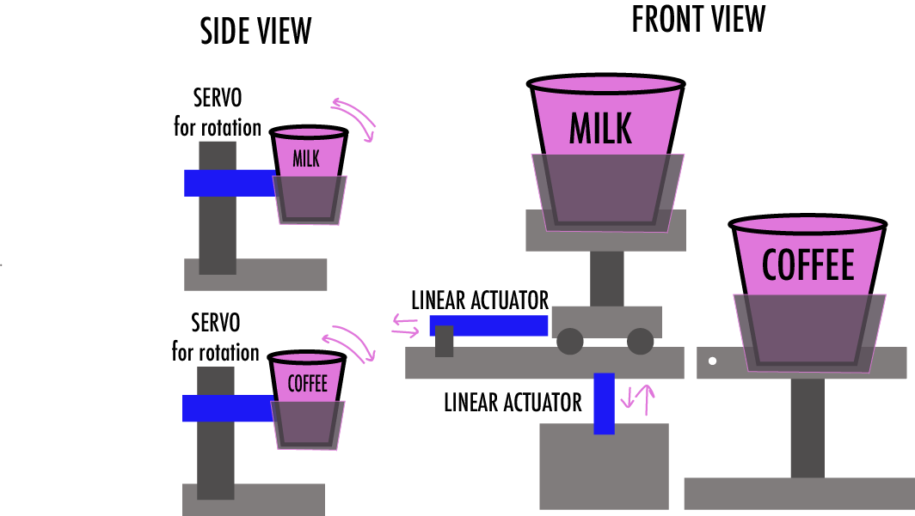

Figure 1: Final Prototype Design

Project Requirements:

Milestone 1: (Project Manager: Leah and Jackie)

Milestone 1 will include finishing the first draft of a physical prototype and demonstration of high level algorithm flow charts and plans for implementation of 2 servos and 2 linear actuators into the design. The coffee cup will demonstrate a range of motion from 0 to 45 degrees. The milk cup will rotate 0 to 150 degrees. The vertical linear actuators will move 4 inches and the lateral linear actuator will move 3 inches.

Milestone 2: (Project Manager: Mariah And Elise )

Milestone 2 will include a refined physical prototype with 2 servos and 2 linear actuators integrated into the design. The code will also rotate the mug for effective latte art pouring. This milestone will demonstrate the tulip design. The tulip design will be validated by having margins within +-10% of the ideal picture of the design. The latte art should fall in the same part of the cup as the demonstrated picture. For example, if the ideal image of the tulip starts 1cm from the bottom of the cup, our art should have similar margins from the outside of the cup.

Final Deliverable: (Project Manager: Derrick and Luke)

The final deliverable will refine the precision of the latte art pouring. It will require that the specifics of the latte art designs are met within ~0.5cm of expected placement when the spout is pouring milk into the mug. The final design will ideally have three different patterns: a heart, a tulip, and a fern. These designs will follow the same constraints as above.

Methodology:

The system will be programmed using Python with a Raspberry Pi. The GUI will also be created with Python and used to start the system. The Raspberry Pi will have 1 stepper motor which will control the angle of tilting for the coffee platform. It will also control two linear actuators used to move the milk horizontally and vertically. Finally, a servo will be used to control the tilting of the milk cup to allow pouring.

The GUI will display the Main Menu upon opening the program. The Main Menu will include 3 separate buttons for each latte art design, a Start button, and an Exit button. The variable that will hold the design the user chooses, ‘designType’, will be set to the default of design 1. If the user selects any of the other designs, said variable will be updated. Once ‘Start’ is selected the hardware program will execute in one of three patterns depending on ‘designType’ and the loading screen will pop up. Once execution is complete, the GUI will return to the Main Menu and the process can repeat until the user ends the program by selecting the ‘Exit’ button.

The motors and actuators will move depending on the ‘designType’ from the GUI. When signaled by the GUI the components will move until signaled to stop.

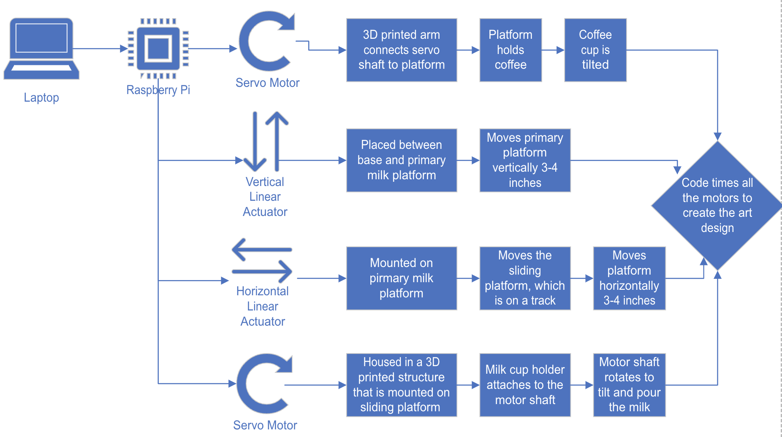

Figure 2: Block Diagram

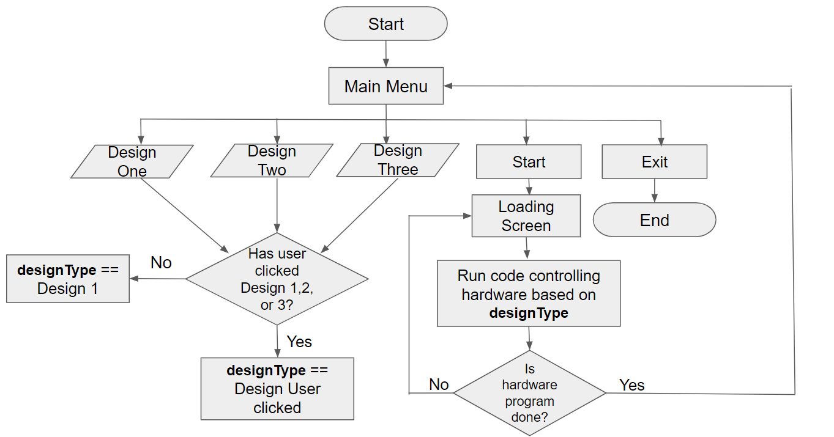

Figure 3: GUI Flowchart

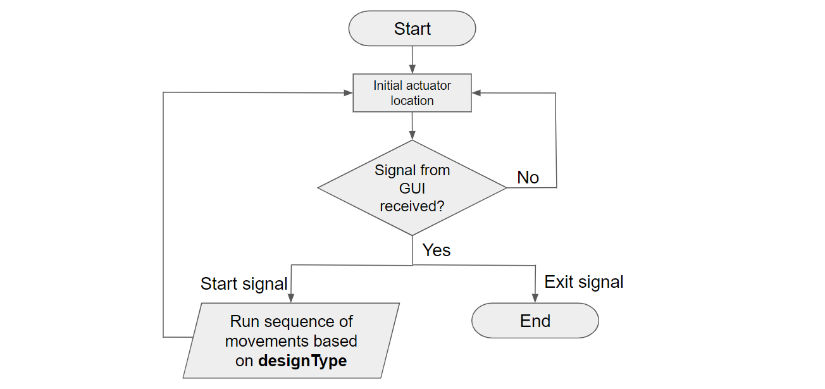

Figure 4: Actuator Control Flowchart

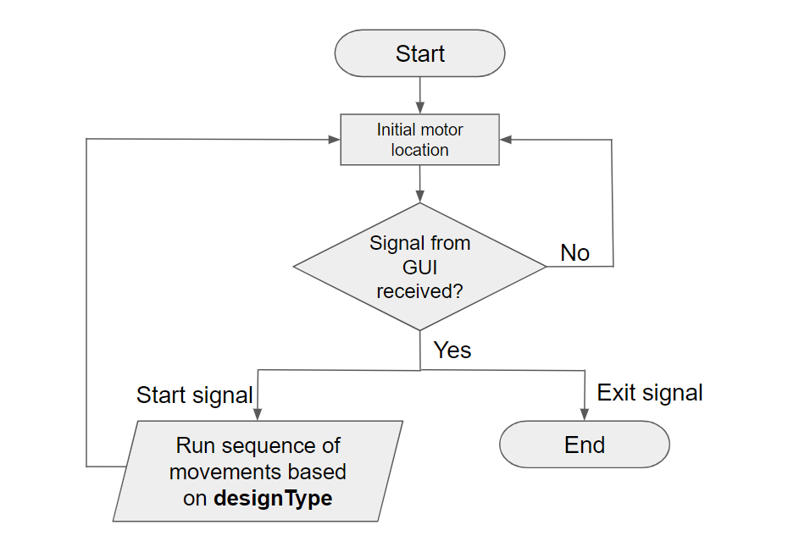

Figure 5: Motor Control Flowchart

Tasks and Precedence Chart:

Task structure

0.0 Build a Latte Art Machine by April 17, 2023 for $450

1.0 Machining

1.1 Tilt Cup

1.2 Elevator Mechanism

1.3 Shift forward and back

1.4 Tilt spout

1.5 Determine timing of movements

1.6 Determine tilt angles

1.7 Program motors and actuators

1.8 Integrate components together

2.0 Materials

2.1 Purchasing

2.2 Delivery

2.3 Creating physical design

2.4 Testing physical design

3.0 Latte/Art

3.1 Frothing Consistency

3.2 Creating designs

3.3 Define quantitative requirements (define successful latte art pours)

3.4 Timing each movement of mug

3.5 Timing each movement of spout

3.5 Program designs/movements

3.6 Create GUI

3.6 Test designs on prototype

Precedence Chart

Precedence Duration

WP1.1 Tilt Cup 2.1 3

WP1.2 Elevator Mechanism 2.1 3

WP1.3 Shift forward and back 2.1 3

WP1.4 Tilt spout 2.1 3

WP1.5 Determine timing of movements 1.1,1.4 4

WP1.6 Determine tilt angles 1.2,1.3 4

WP1.7 Program motors and actuators 1.5,1.6 10

WP1.8 Integrate components together 1.7 12

WP2.1 Purchasing None 2

WP2.2 Delivery 2.1 7

WP2.3 Creating physical design 2.2 20

WP2.4 Testing physical design 1.8,2.3 7

WP3.1 Frothing consistency None 2

WP3.2 Creating designs 3.1 5

WP3.3 Define quantitative requirements 3.2 1

WP3.4 Timing each movement of mug 3.3 3

WP3.5 Timing each movement of spout 3.3 7

WP3.6 Program designs/movements 2.4,3.4,3.5 20

WP3.7 Create GUI None 2

WP3.8 Test designs on prototype 3.6 6

Resource Planning Matrix:

Skills Equipment Material

WP1.1 Tilt Cup Python Raspberry Pi Motors

WP1.2 Elevator Mechanism Python Raspberry Pi Actuator

WP1.3 Shift forward and back Python Raspberry Pi Actuators

WP1.4 Tilt spout Python Raspberry Pi Motor

WP1.5 Determine timing of movements

WP1.6 Determine tilt angles

WP1.7 Program motors and actuators Python Raspberry Pi Motor, actuators

WP1.8 Integrate components together Python Raspberry Pi Motor, actuators

WP2.1 Purchasing

WP2.2 Delivery

WP2.3 Creating physical design SolidWorks 3D printer, solder Motor, actuators,

cups, spout. PLA

WP2.4 Testing physical design Raspberry Pi

WP3.1 Frothing consistency Espresso Machine, Coffee, Milk,

Frother Cups

WP3.2 Creating designs Latte Art Espresso Machine, Coffee, Milk,

Frother Cups

WP3.3 Define quantitative requirements

WP3.4 Timing each movement of mug Espresso Machine, Coffee, Milk,

Frother, Clock Cups

WP3.5 Timing each movement of spout Espresso Machine, Coffee, Milk,

Frother, Clock Cups

WP3.6 Program designs/movements Python Raspberry Pi

WP3.7 Create GUI Python Raspberry Pi

WP3.8 Test designs on prototype Espresso Machine, Coffee, Milk, Frother, Raspberry Pi Cups, Motors,

Actuator

Responsibility Requirement Matrix: (OS = Oversee)

Derrick Elise Jackie Leah Luke Mariah WP1.1 Tilt Cup OS OS

WP1.2 Elevator Mechanism OS OS

WP1.3 Shift forward and back OS OS

WP1.4 Tilt spout OS OS

WP1.5 Determine timing of movements OS

WP1.6 Determine tilt angles OS

WP1.7 Program motors and actuators OS

WP1.8 Integrate components together OS OS OS

WP2.1 Purchasing OS

WP2.2 Delivery OS

WP2.3 Creating physical design OS OS OS

WP2.4 Testing physical design OS OS OS

WP3.1 Frothing consistency OS OS

WP3.2 Creating designs OS OS

WP3.3 Define quantitative requirements OS

WP3.4 Timing each movement of mug OS OS

WP3.5 Timing each movement of spout OS OS

WP3.6 Program designs/movements OS OS OS

WP3.7 Create GUI OS OS OS

WP3.9 Test designs on prototype OS OS OS OS OS OS

Network Diagram:

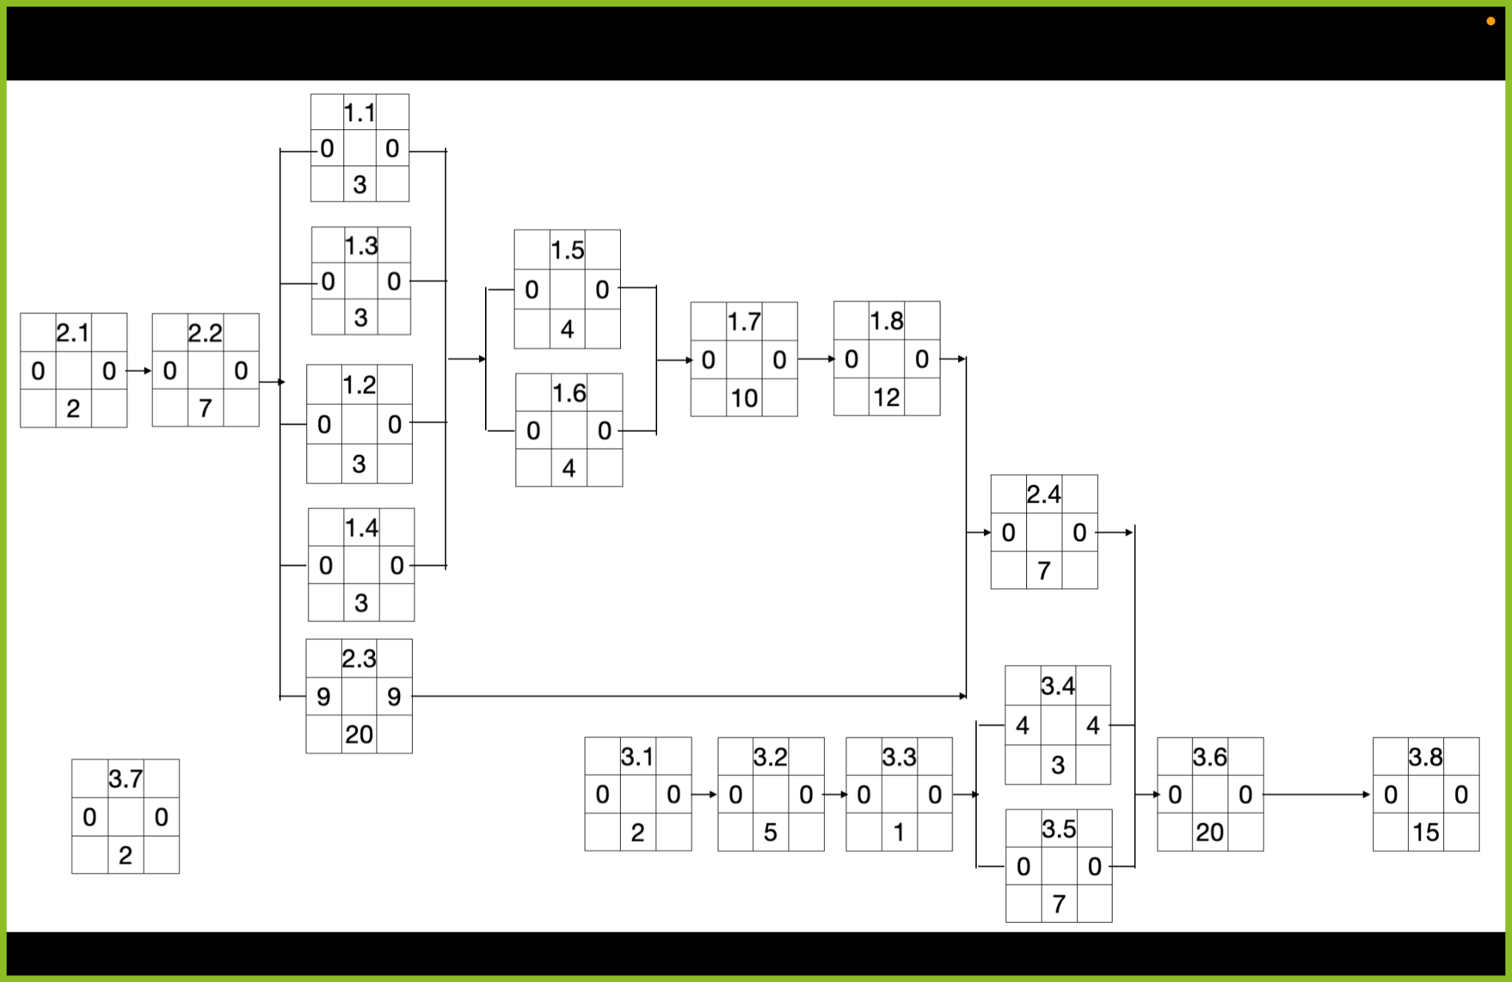

Start and Finish Chart:

Start Finish

WP1.1 Tilt Cup 2/10 2/13

WP1.2 Elevator Mechanism 2/10 2/13

WP1.3 Shift forward and back 2/10 2/13

WP1.4 Tilt spout 2/10 2/13

WP1.5 Determine timing of movements 2/13 2/17

WP1.6 Determine tilt angles 2/13 2/17

WP1.7 Program motors and actuators 2/17 2/27

WP1.8 Integrate components together 2/27 3/11

WP2.1 Purchasing 2/1 2/3

WP2.2 Delivery 2/3 2/10

WP2.3 Creating physical design 2/10 3/2

WP2.4 Testing physical design 3/11 3/18

WP3.1 Frothing consistency 2/1 2/3

WP3.2 Creating designs 2/3 2/8

WP3.3 Define quantitative requirements 2/8 2/9

WP3.4 Timing each movement of mug 2/9 2/12

WP3.5 Timing each movement of spout 2/12 2/19

WP3.6 Program designs/movements 3/18 4/7

WP3.7 Create GUI 2/1 2/3

WP3.8 Test designs on prototype 4/7 4/16

Gantt Chart:

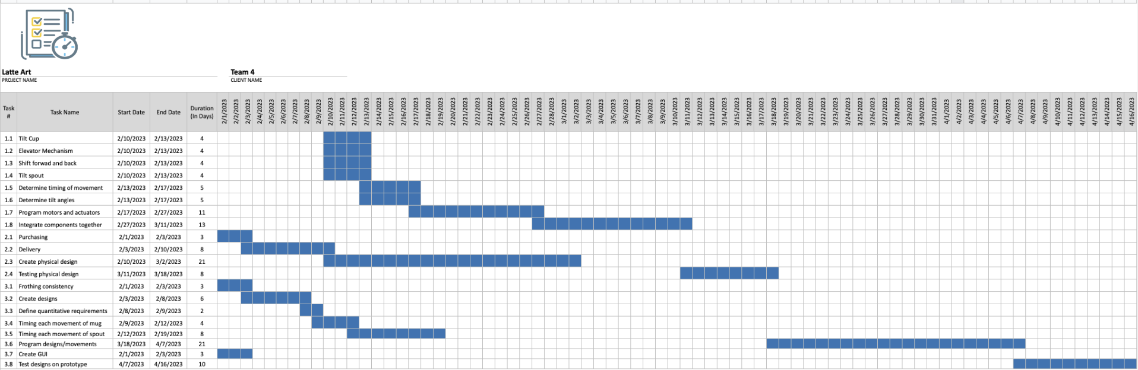

Risk Management Chart:

| **Risks Identified** | **Risk Assessment** | **Preventative Actions** | **Contingencies** |
| --- | --- | --- | --- |
| Delay of Materials | Supply Chain | Purchase materials as soon as possible | Change materials to components that will get here in time to build our design |
| Liquid spill on electrical equipment | User error | Wrap all electrical components in spill-proof casings | Purchase extra components (within reason) in case any need replacement due to damage |
| Team members get sick/out of town/unable to meet |  | Communicate as soon as possible | Establish Zoom option for meetings. |

References:

[1] <https://pic-microcontroller.com/ece-4760-latte-art-machine/amp/>

[2] [Drawing.vsdx](https://clemson-my.sharepoint.com/:u:/r/personal/ldb_clemson_edu/Documents/Drawing.vsdx?d=w63b811091e644d569dec168233f1b09b&csf=1&web=1&e=feHzgb)

[3]<https://medium.com/geekculture/gpio-programming-on-the-raspberry-pi-python-libraries-e12af7e0a812>

[4] <https://gpiozero.readthedocs.io/en/stable/>

Add more references if applicable.